**GNSS Navigation Lab (Sept 2024 version)**

# **Lab introduction:**

Global Navigation Satellite Systems (GNSS) is a cornerstone of modern positioning, navigation, and timing (PNT) technologies. They provide accurate location and time information to users anywhere on Earth, under any weather conditions, and at any time. GNSS positioning has revolutionized many aspects of modern life, providing critical data for navigation, timing, and location-based services. As technology continues to advance, GNSS will become even more integral to our daily activities and various industries.

The GNSS navigation lab focuses on the data collection of the GNSS receiver and its data processing using Python programming. The student is expected to learn to use the GNSS receiver to collect the data and process the GNSS data, such as the GNSS single point positioning, and GNSS velocity estimation using the Doppler measurements. The expected learning outcome of this lab is as follows:

* *Objective 1*: Learn to use the usage of the GNSS data collection software, such as the u-center for the u-blox receiver data collection, and the GNSS Logger for GNSS data collection from the Android smartphone.
* *Objective 2*: GNSS data processing using the RTKLIB, including the position and velocity estimation.
* *Objective 3*: GNSS data processing using Python programming, including position and velocity estimation.
* *Objective 4*: Learn the analysis of the data, such as the comparison of the GNSS velocity results based on the position differential and the Doppler measurement-based velocity estimation. All these should be done using the Python code.

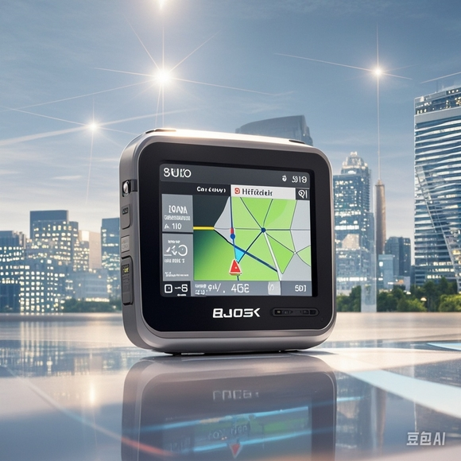

Fig 1: (Left) Smartphone-based GNSS positioning in urban canyons. (Right) GNSS receiver-based positioning in urban canyons.

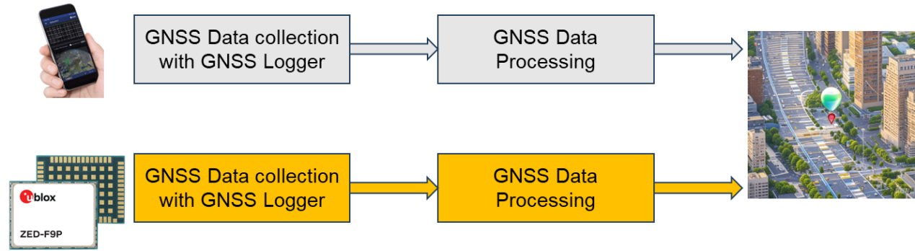 Fig 2: Overview of the lab. Two sets of GNSS receivers could be used for the data collection.

# **Q&&A**

* **Lecturer**: [Dr. Weisong Wen](https://www.polyu.edu.hk/aae/people/academic-staff/dr-wen-weisong/" \o "https://www.polyu.edu.hk/aae/people/academic-staff/dr-wen-weisong/), [Department of Aeronautical and Aviation Engineering](https://www.polyu.edu.hk/aae/" \o "https://www.polyu.edu.hk/aae/) (AAE)
* **Address**: PQ408, PolyU.
* **Email**: [welson.wen@polyu.edu.hk](mailto:welson.wen@polyu.edu.hk" \o "mailto:welson.wen@polyu.edu.hk)
* **Teaching Assistant**: Ruijie Xu, Xikun Liu, Yuan Li, Yihan Zhong.
* **Lecture Venue and Time**: BC303, Thu 15:30-18:20
* **Github issue**: <https://github.com/weisongwen/AAE4203-2425S1/issues>

1. **GNSS positioning and analysis using u-blox receiver**

**3.1 u-blox receiver**

u-blox provides commercial-grade GNSS receivers that support multi-constellation and multi-band signals for precise positioning.

The ZED-F9P module is one of the high-precision GNSS receivers in the u-blox F9 series, featuring:

* Multi-band GNSS Receiver: Supports concurrent reception of multiple GNSS constellations (GPS, GLONASS, Galileo, BeiDou).
* Centimeter-Level Accuracy: Achieves centimeter-level accuracy using Real-Time Kinematic (RTK) positioning, providing high precision in seconds.
* Concurrent Multi-Constellation Reception: Receives signals from various constellations simultaneously, improving accuracy and reliability.
* Small and Power-Efficient: The ZED-F9P module is compact and energy-efficient, making it suitable for integration into a variety of devices.
* 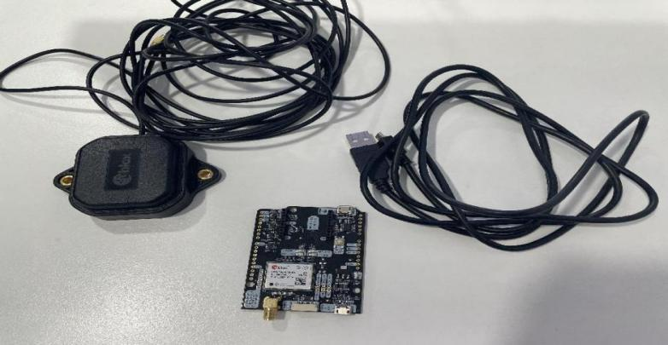Fast RTK Integration: The module simplifies RTK integration for quick time-to-market, ideal for applications requiring high-precision positioning, such as autonomous driving, drones, and precision agriculture.

**3.2 Data Collection with u-blox Receiver**

**3.2.1 Installation and Hardware Setup**

* **Connect the Antenna:**

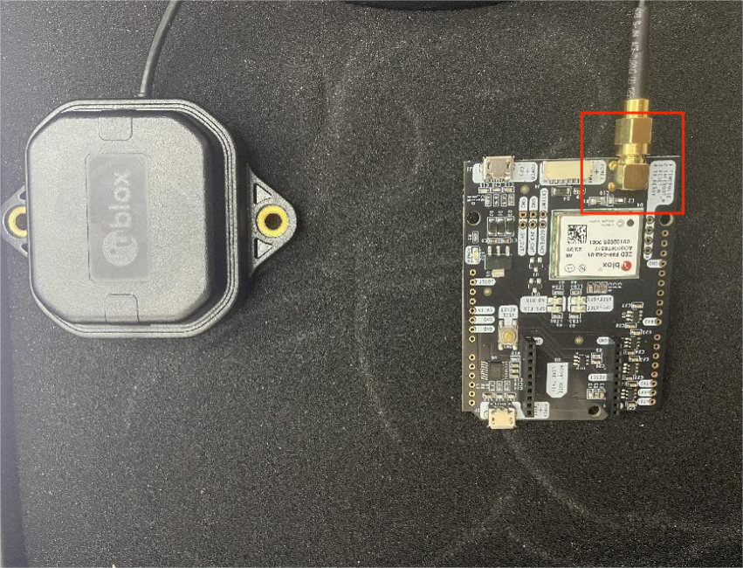Connect a high-precision GNSS antenna to the ZED-F9P module. Ensure the antenna is positioned in a location with a clear view of the sky to optimize satellite signal reception.

* **Connect the Module:**

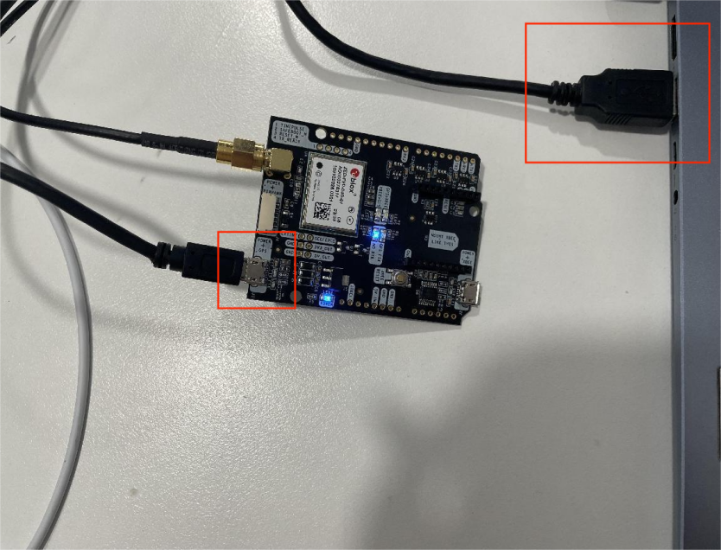

**3.2.2 Using u-center for GNSS Data Collection**

u-blox provides u-center, a powerful evaluation software tool designed to configure, monitor, and analyze GNSS data. Follow these steps to collect data with u-center:

* **Download and Install u-center:**

<https://www.u-blox.com/en/product/u-center>

* **Connect and Recognize the Device:**

Open u-center, navigate to the Receiver menu, and select Connection. Ensure the software detects the connected ZED-F9P receiver.

Choose the correct COM port and set the baud rate (typically 9600 or 115200) to establish proper communication.

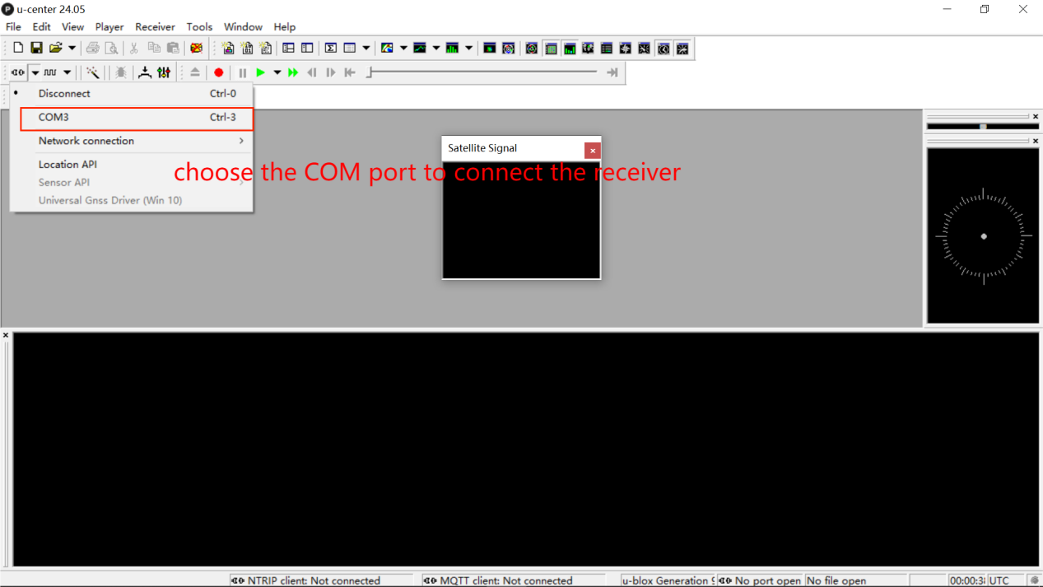

Once the receiver is connected, u-center will begin displaying real-time data from multiple GNSS constellations, including satellite count, signal strength, and positional coordinates.

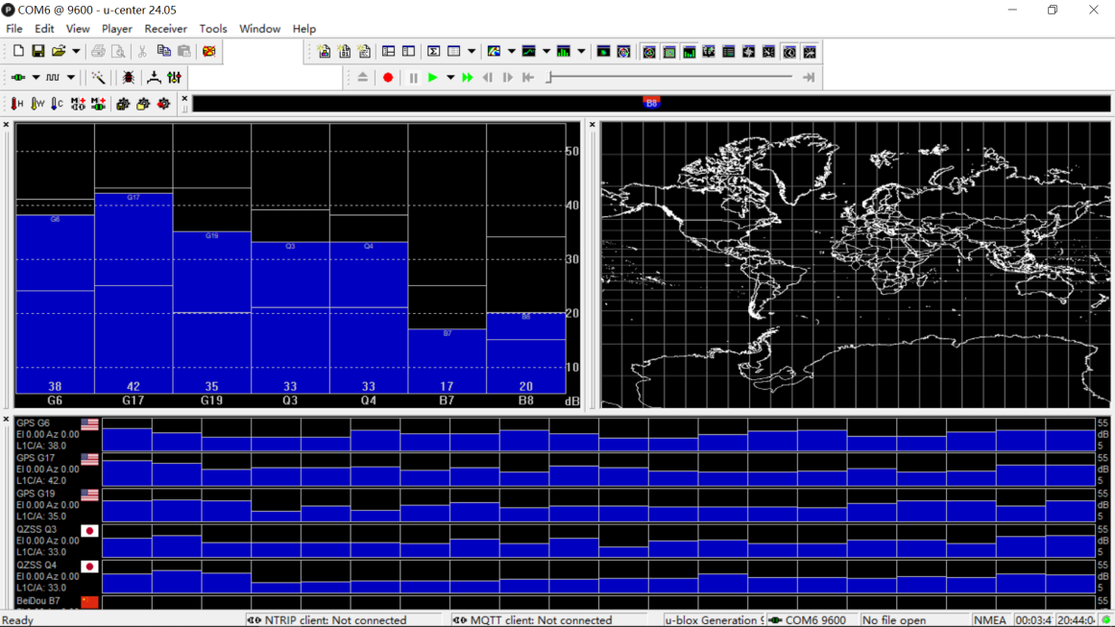The Satellite View screen allows you to visualize the status of each satellite being received.

* 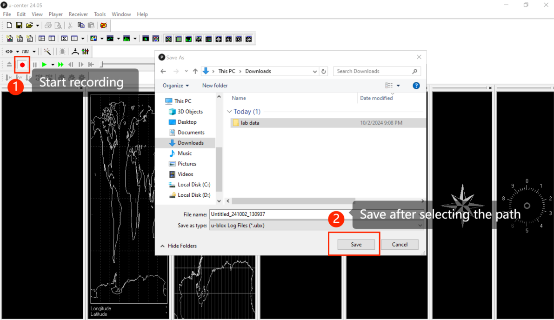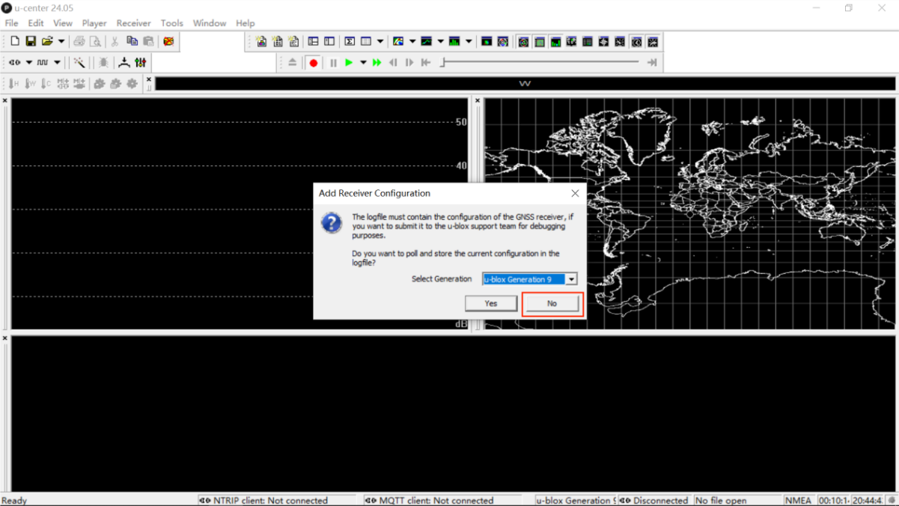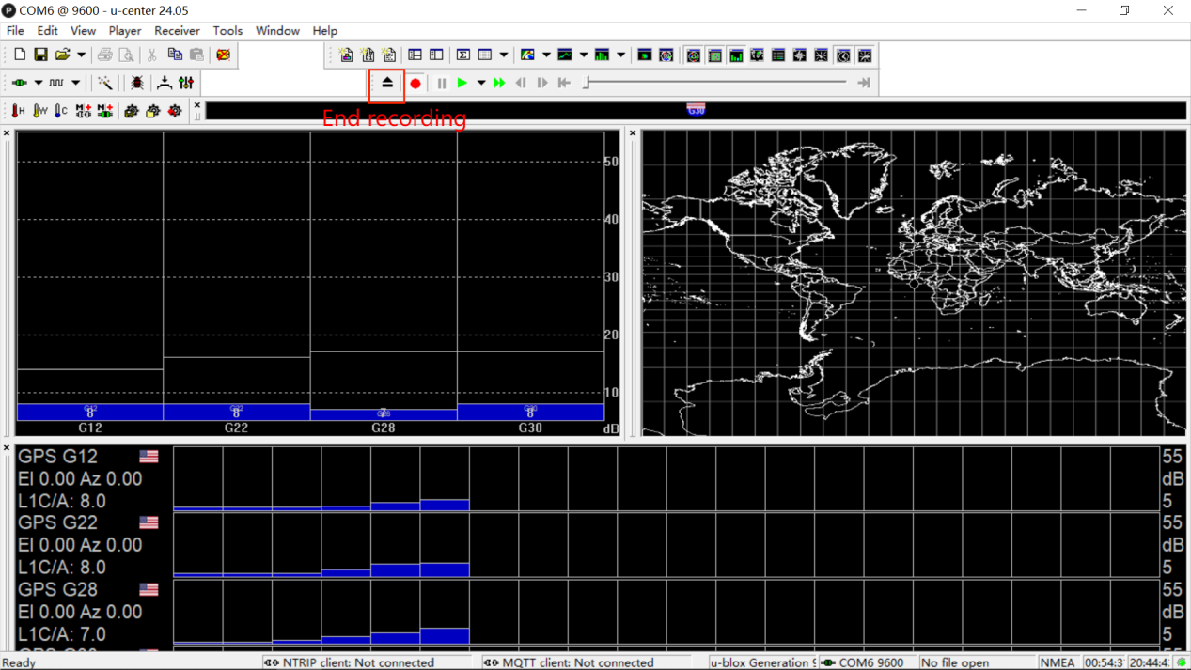**Record GNSS Data:**

**3.3 data analysis with RTKLIB**

RTKLIB is an open-source software library for GNSS data processing, supporting Real-Time Kinematic (RTK) and post-processing modes.

**3.3.1 Install and Set Up RTKLIB**

* Download and install RTKLIB

<https://www.dropbox.com/scl/fo/32trvbm868h038lfwg9mg/AFLja6jU3qK55FRuiUoto_c?rlkey=lg1gzafo58xcktltzm7fpg118&dl=0>

* Open “rtklauch.exe”.

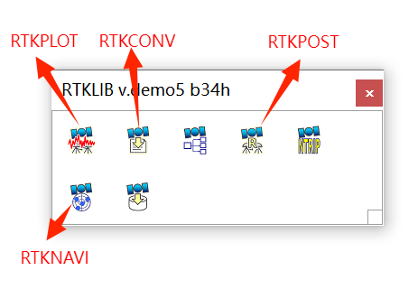

RTKPOST: For post-processing GNSS data.

RTKNAVI: For real-time data processing.

RTKCONV: For converting raw GNSS data formats.

RTKPLOT: For visualizing and analyzing the results.

**3.3.2 Data Format Conversion**

Use RTKCONV to convert raw data (ubx file saved by u-center) to RINEX format.

* Open RTKCONV and select the raw input file.

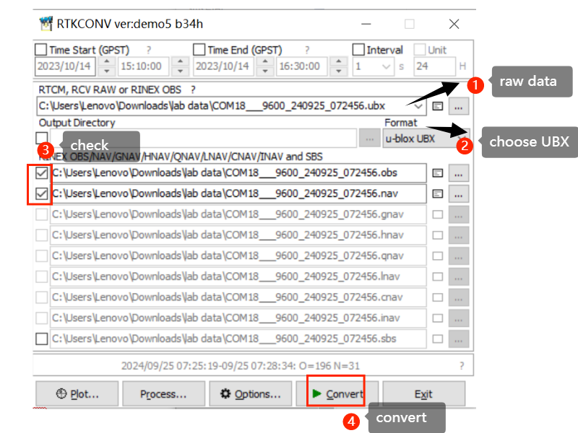Configure output options, typically to RINEX observation (.obs) and navigation (.nav) files.

**3.3.3 Data Preparation**

* Observation Data: RINEX files (.obs) containing raw GNSS observations (e.g., carrier phase, pseudorange).
* Navigation Data: RINEX files (.nav) containing satellite ephemeris and clock information.
* Base Station Data: For RTK processing, base station data is required as a reference. This should include both observation and navigation files.

<https://www.geodetic.gov.hk/tc/rinex/downv.aspx>

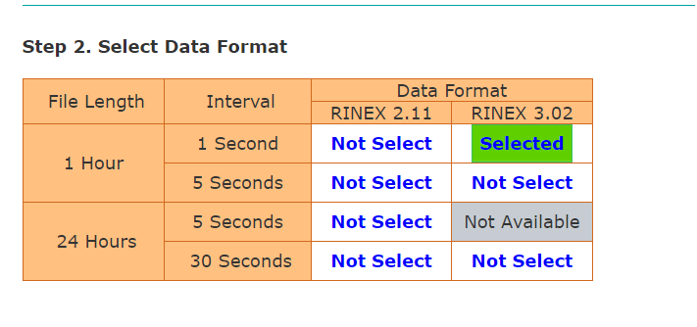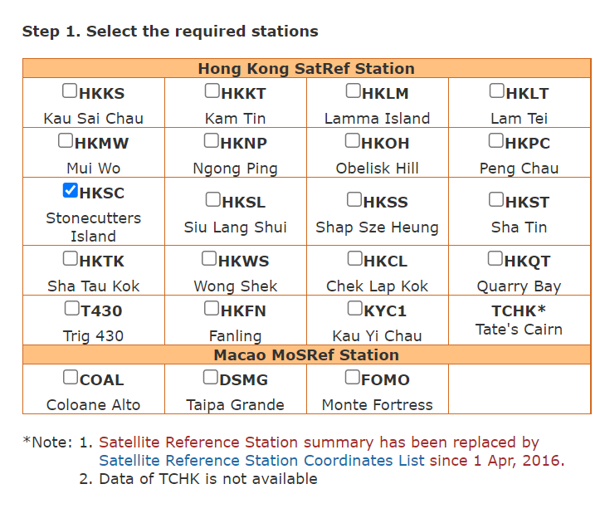

|  |  |
| --- | --- |
|  | *Select the ephemeris time period based on the time period in the RENIX format observation file (UTC=HKT-8) |
|  |

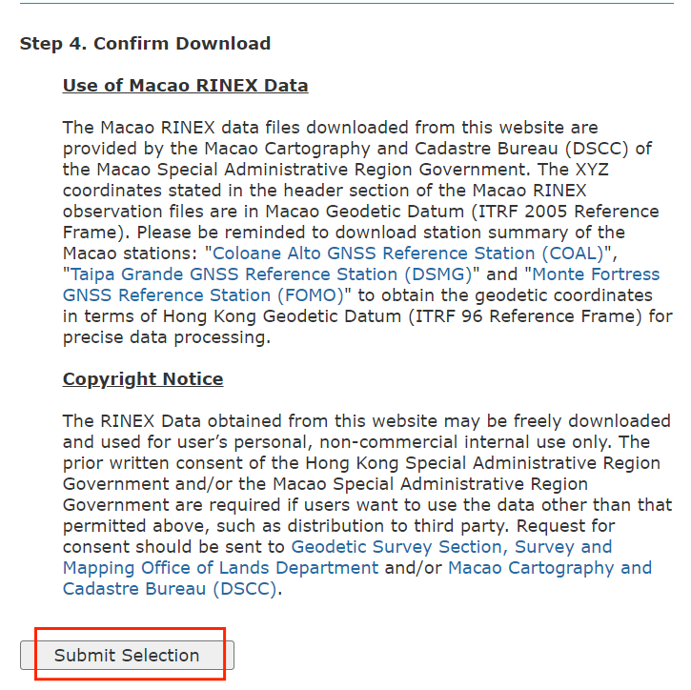

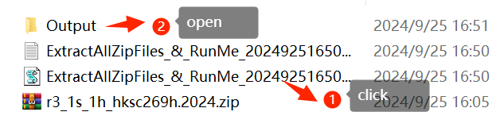Extract the ZIP file.

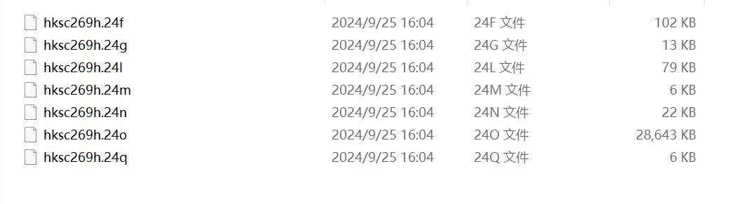

|  |  |
| --- | --- |
| “.o”: Base station data | “.n”: GPS (USA) |
| “.q”: QZSS (Japan) | “.f”: BeiDou (China) |
| “.g”: GLONASS (Russia) | “.l”: Galileo (Europe) |

**3.3.4 Configure Processing Options**

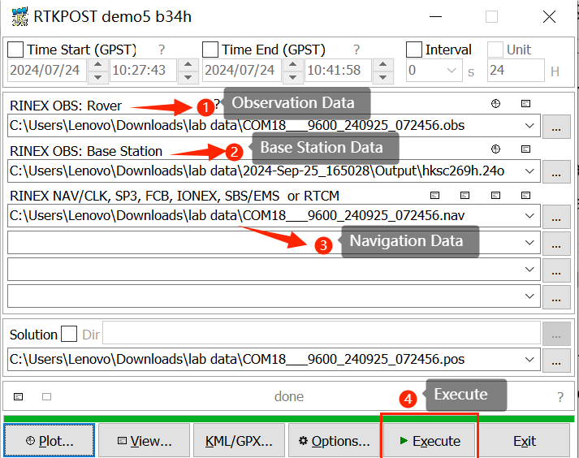Open the RTKPOST and upload the observation file and navigation file output by RTKCONV, along with the base station data, to the corresponding locations and then execute.

**3.3.5 View and Analyze Results**

* 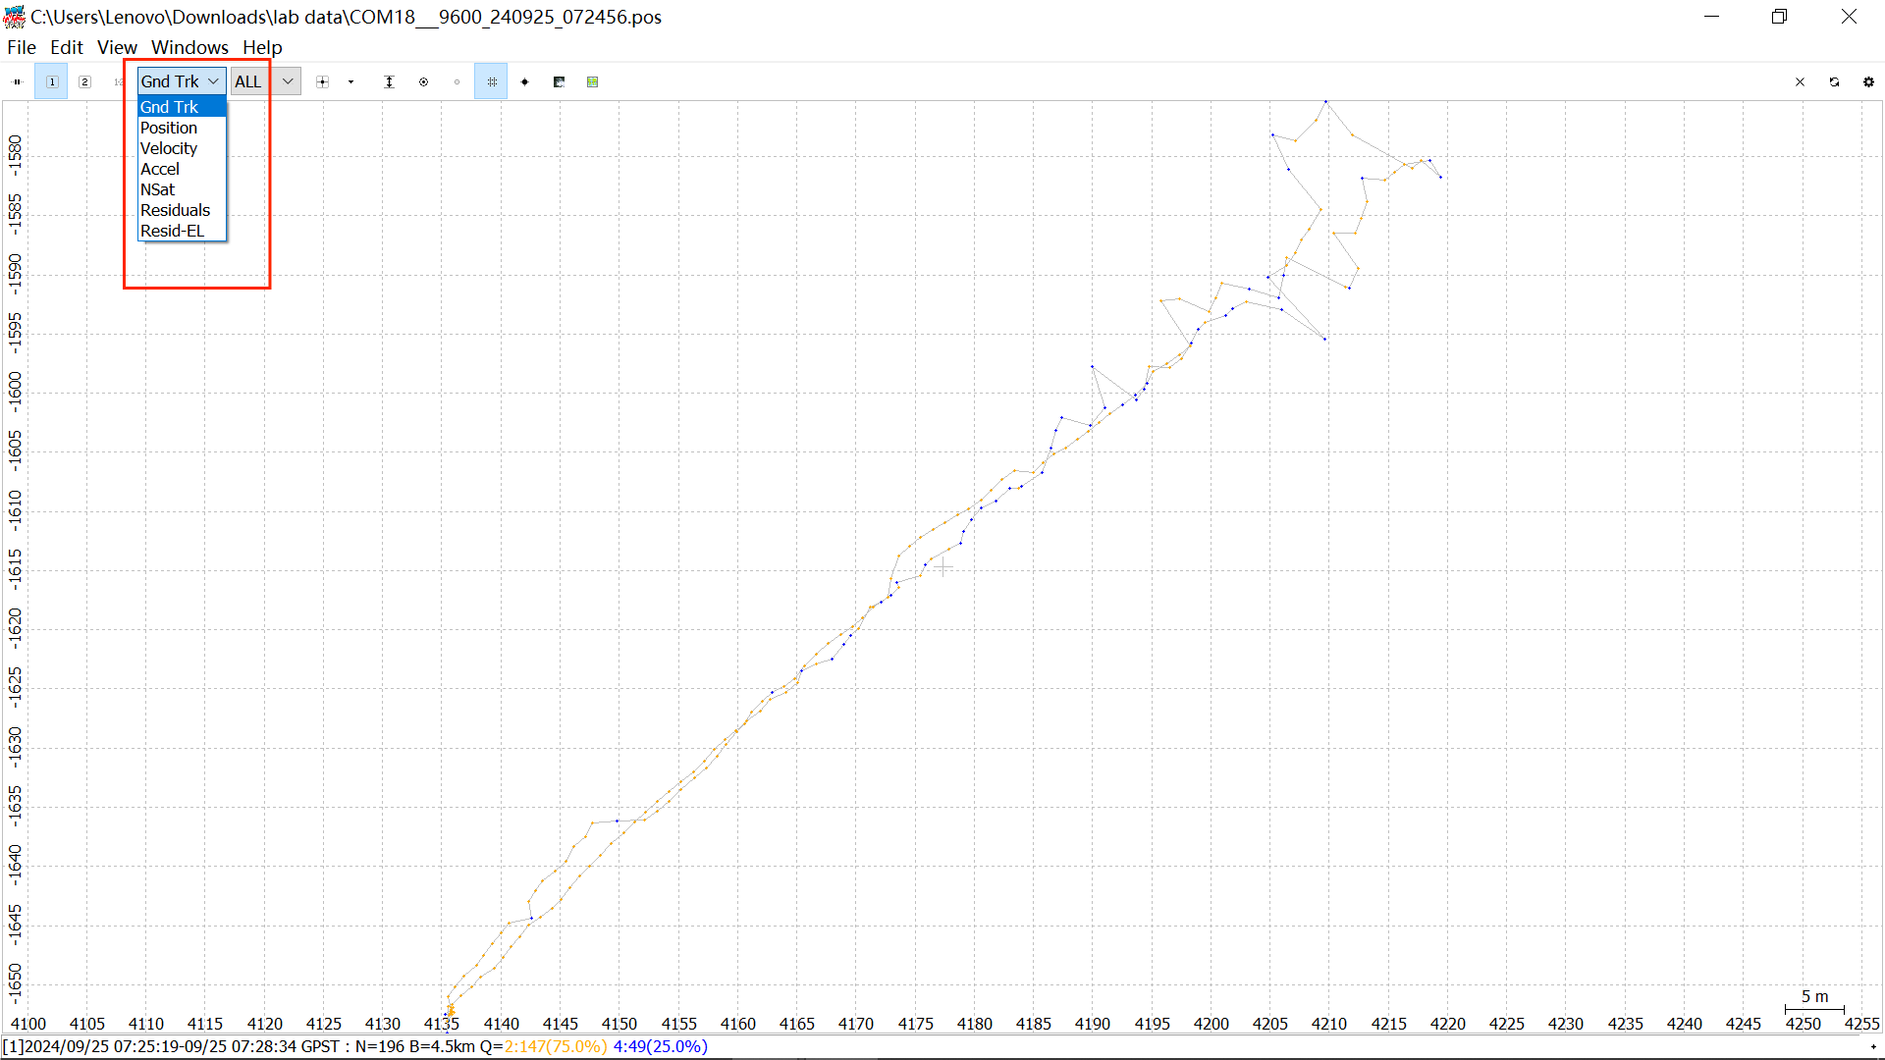Display the path in rtklib

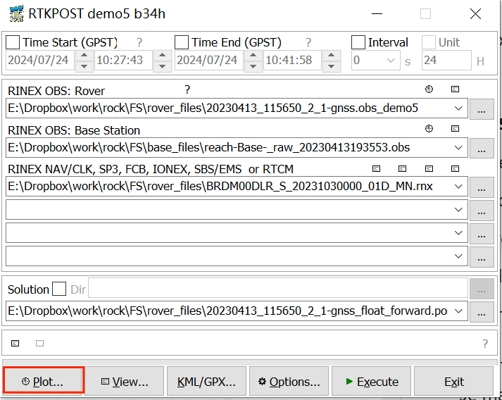

* Display the path in Google Earth

You can choose to use the Google Maps web version or download the Google Maps app.

Web:<https://earth.google.com/web/@0,0,0a,22251752.77375655d,35y,0h,0t,0r/data=CgRCAggBSg0I____________ARAA>

Download link:<https://www.google.com/earth/about/versions/>

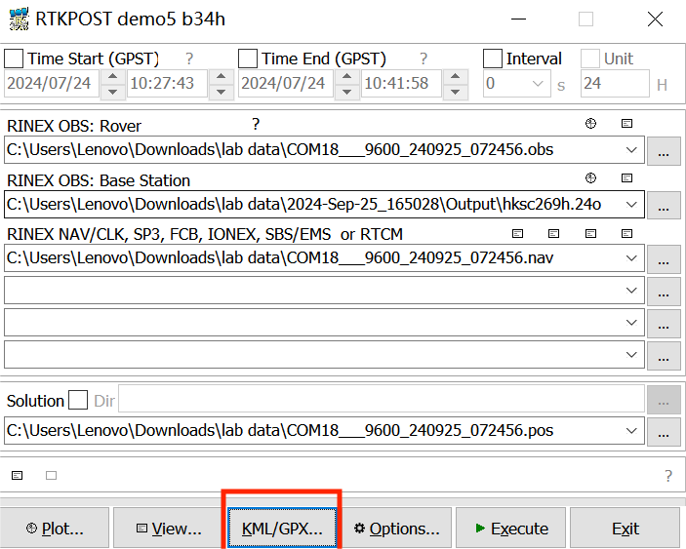

App:

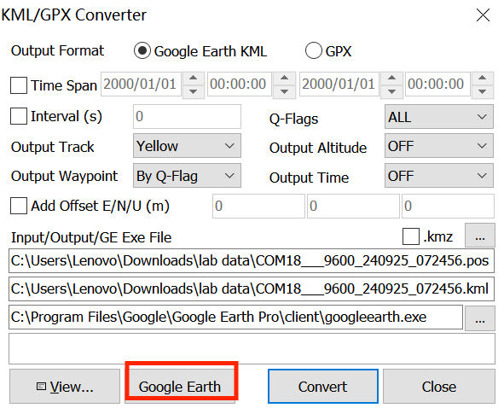

Web:

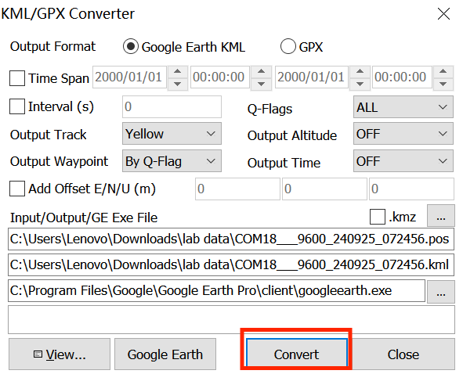

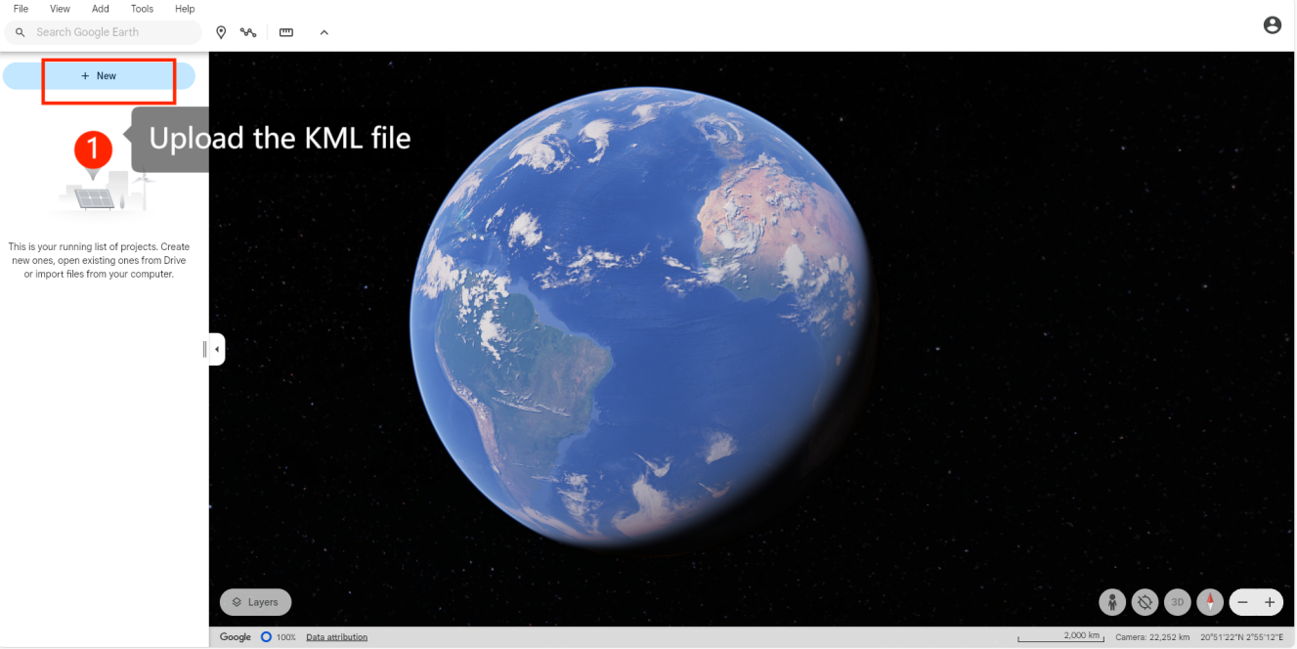

# **GNSS positioning and analysis using a smartphone receiver**

## 4.1 smartphone receiver

Using the smartphone Pixel 6 to collect data, GNSS hardware has been integrated into the smartphone. The software for data collection is the GnssLogger app.

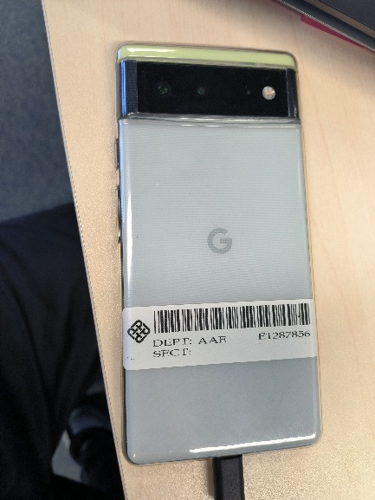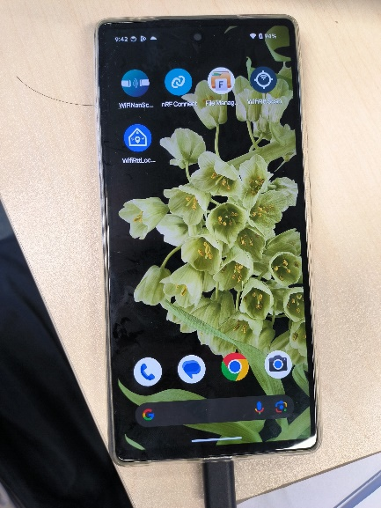

## 4.2 data collection with smartphone receiver

See the video: https://www.bilibili.com/video/BV1qDsYe5EQA/

1. Collect data:Open the GnssLogger app in the smartphone, and click the start log, the GNSS data will be collected. When the data collection is complete, click stop.

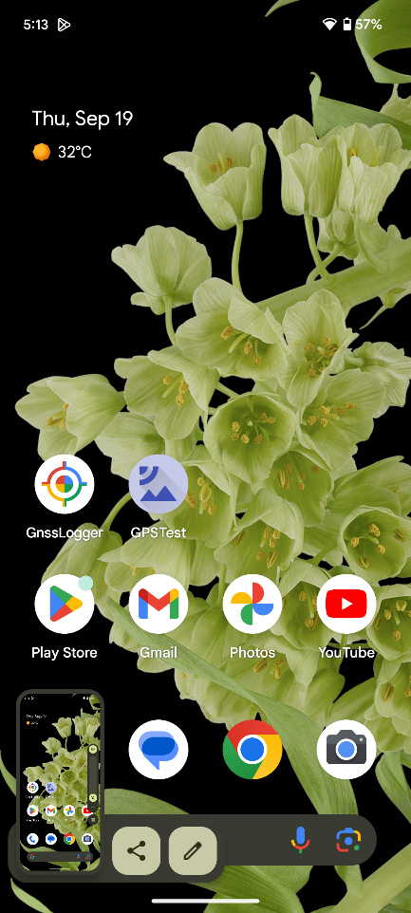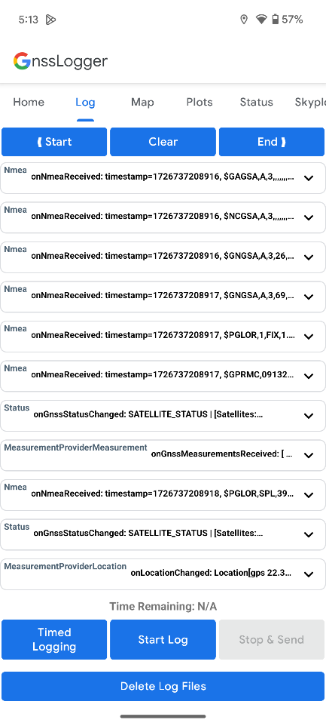



2. Get the data from the smartphone:

(a) Use the USB to connect the smartphone to the computer.

(b) Enter the path \Pixel 6\Internal shared storage\Android\data\com.google.android.apps.location.gps.gnsslogger\files\gnss_log\

(c) Copy the corresponding data to the matlab folder according to the file time, which includes “.24o”, “.nmea”, “.txt” file

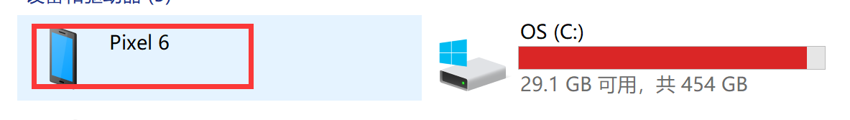

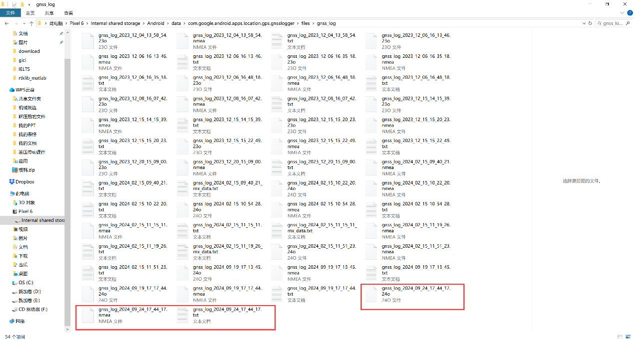

## 4.3 data analysis with Sing positioning

1. Download the navigation file in the [Geodetic Survey of Hong Kong](https://www.geodetic.gov.hk/en/rinex/downv.aspx).

(a) Click the HKSC

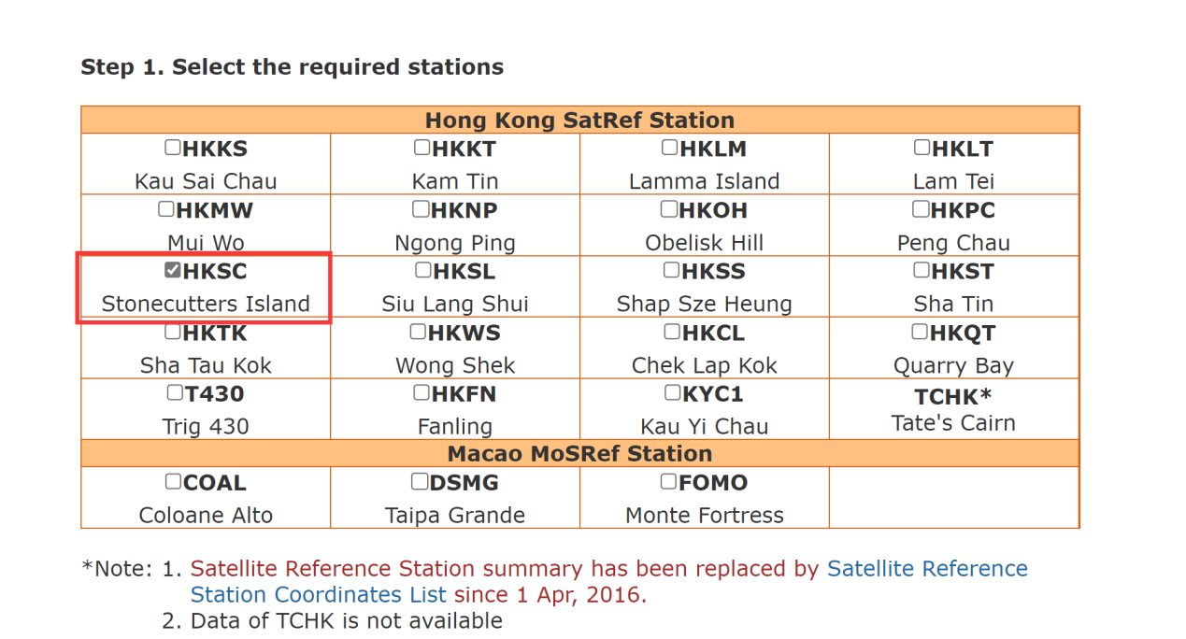

(b) Select 1 hour and RINEX 3.02 format

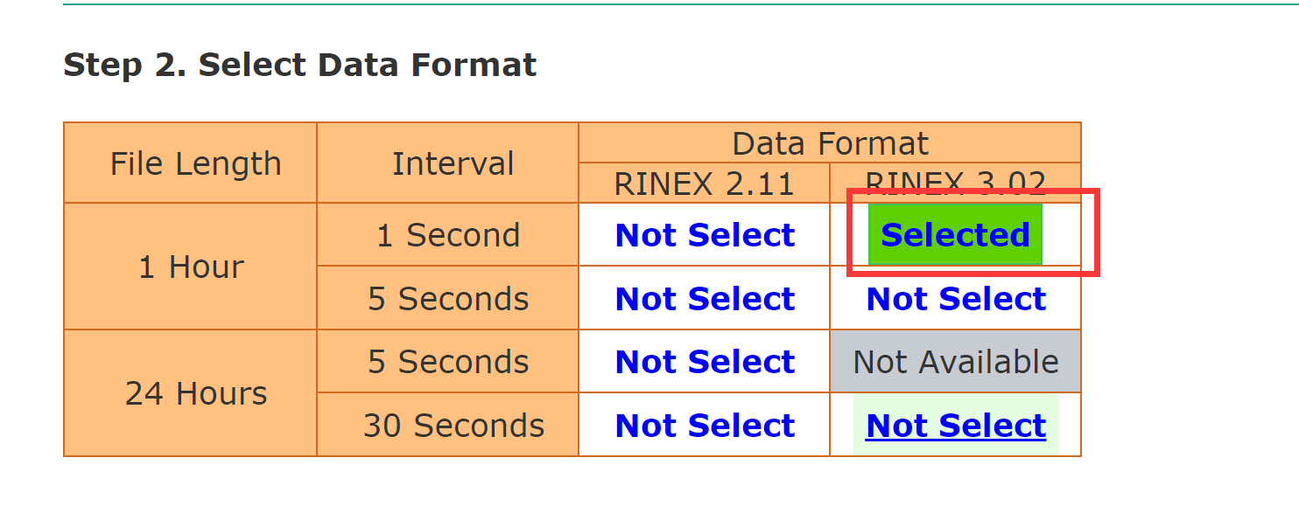

(c) Choose the time form the .24o file (which is got by step 2, use the vscode sofeware)

2024 09 19 09 14 (time:2024/09/19 09:14)

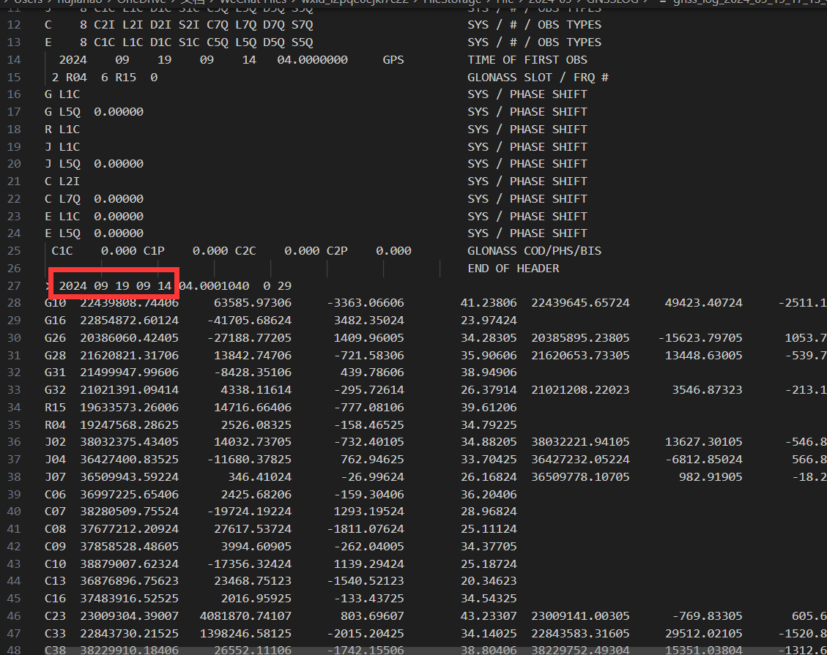

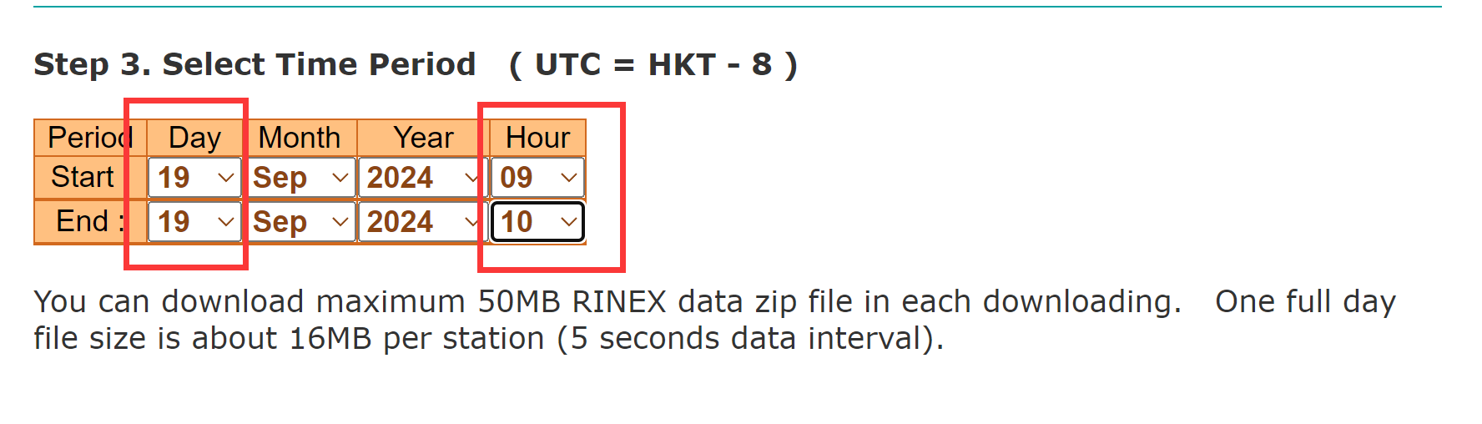

(d) Click the submit selection

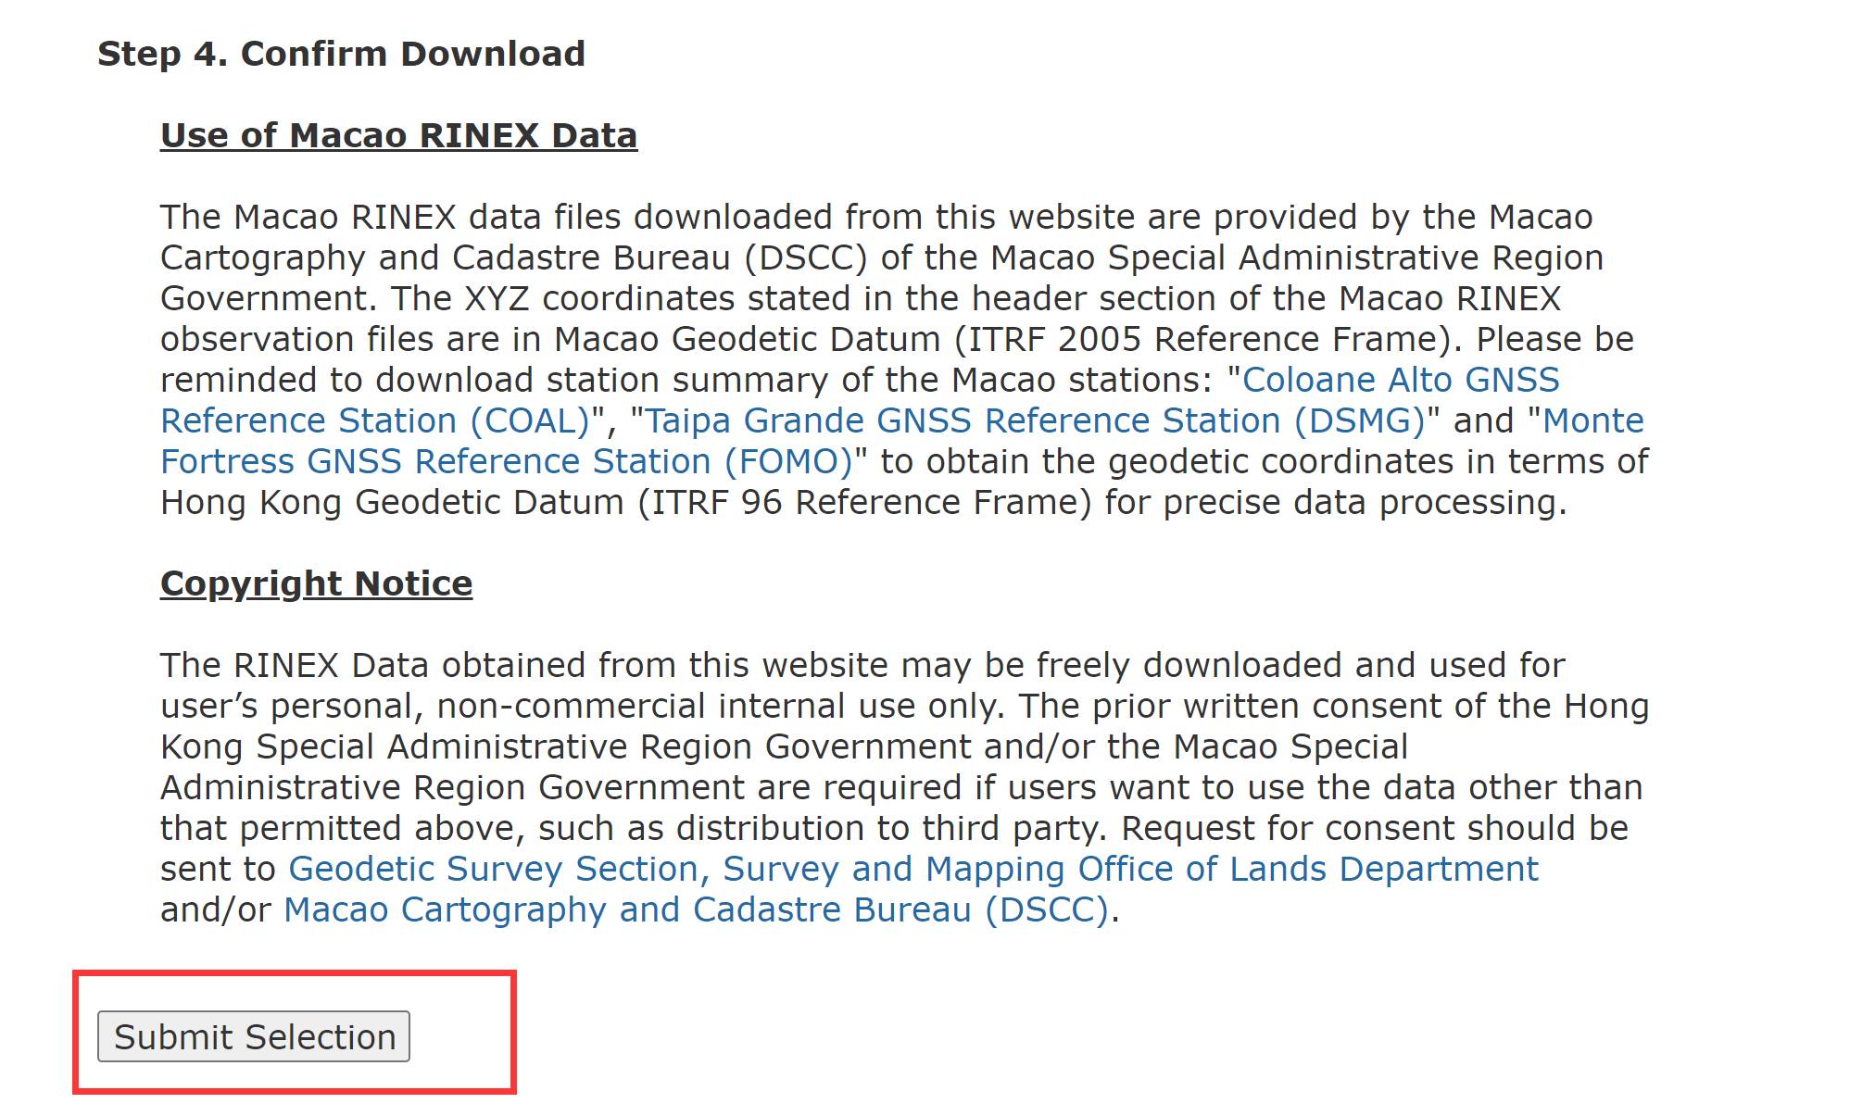

(e) Click the download button

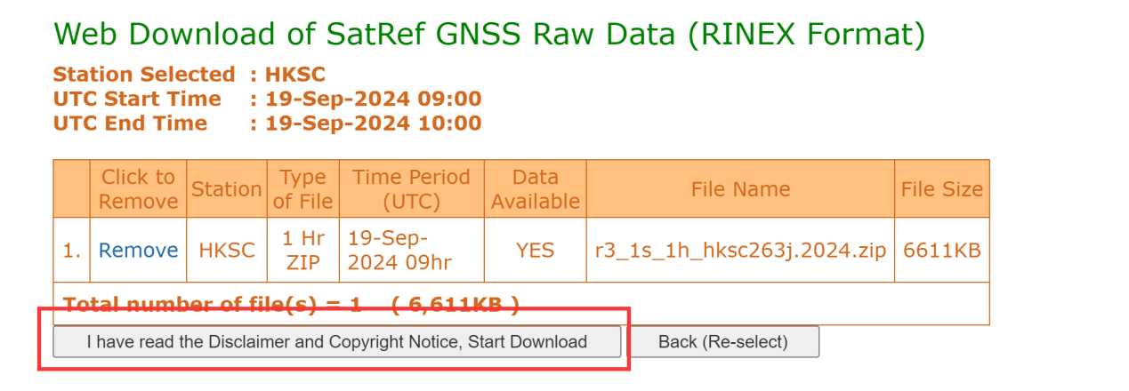

(e) Unzip the file, and double-click the .vbs file, to get the navigation file.

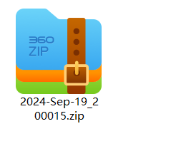

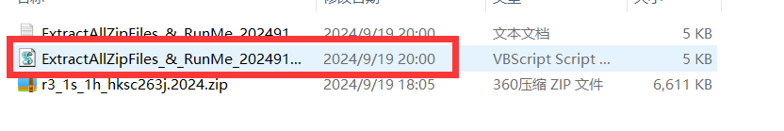

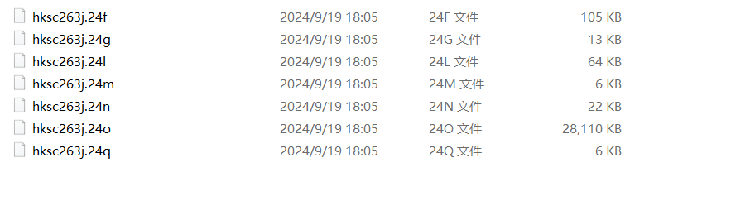

(f) Move all files of the output folder to the smartphone gnss .obs file (for example, E:\TA\rtklib_matlab\data\2024_0919)

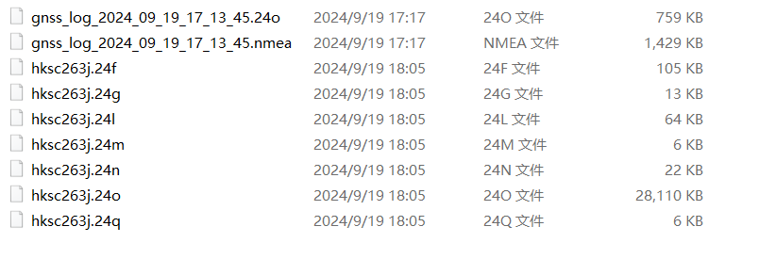

2. Obtain the ionospheric, tropospheric, pseudoranges, satellite clock bias and satellite positions.

Open the Matlab, run the generate_the_data.m, and get the ionospheric_delay.csv,

pseudoranges_meas.csv, satellite_clock_bias.csv, satellite_positions.csv, tropospheric_delay.csv files.

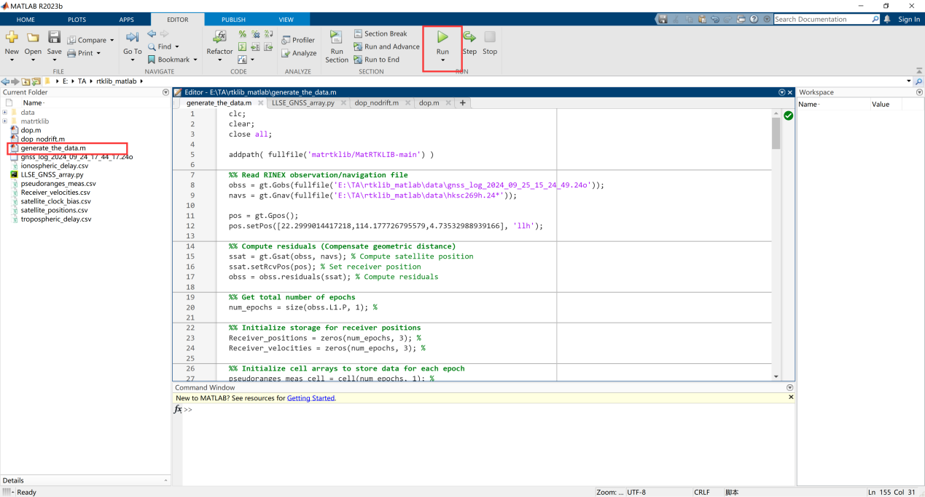

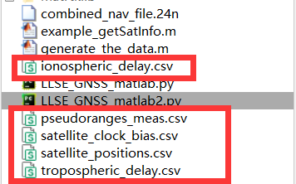

3. Use the python program of least square method to deal with the data, and get the position.

(a)Open the python program, “LLSE_GNSS_array.py” ,and change the file path, as shown below.

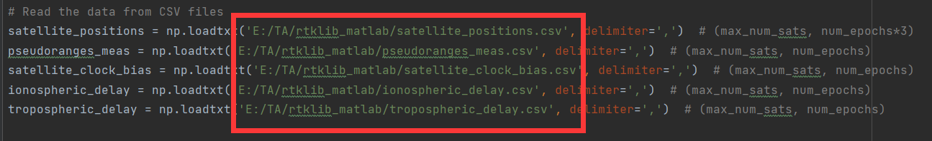

(b) Run the Python program and get two graphs, the first graph is the longitude and latitude coordinates, and the second is the ENU coordinates.

